SELF PURSUED PROJECT

PROJECT TITLE:
Breast Cancer Classification

Ajay Bhat

Year: 2020



Signature of the Project Student
- Project Title: Ukulwa – The Breast Cancer Detector ( Classifier)

- Broad Subject: Machine Learning, Support Vector Machine, Classification

- Motivation: Breast cancer is the most common cancer among women worldwide. Accounting for 25% of all cancer cases and affecting 2 million people every year. Early diagnosis significantly increases the chances of survival. The key challenge in cancer detection is to classify tumours into malignant or benign.
Machine Learning techniques can dramatically improve the accuracy of diagnosis. Research indicates most experiences physicians can diagnose cancer cases with 79% accuracy. While 91% (up to 97%) correct diagnosis is achieved using machine learning techniques.

- Objective: In this case study our task is to classify tumours into malignant or benign tumours based on features obtained from several cell diagnoses.


CANCER DIAGNOSIS PROCEDURE:
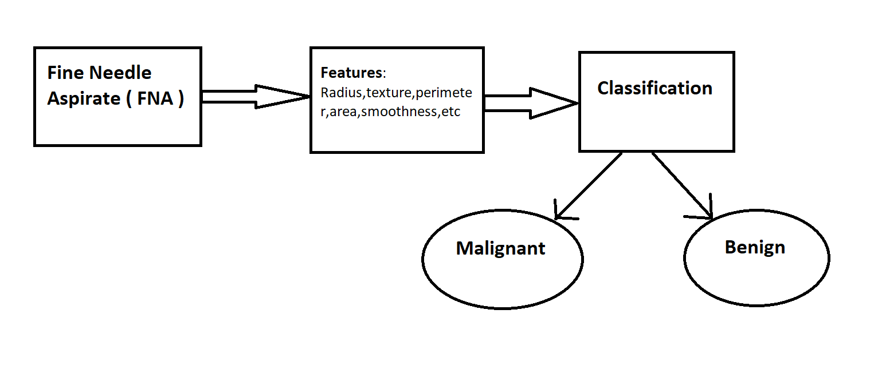
- The first step in cancer diagnosis process is Fine Needle Aspirate (FNA).
- The cell extract obtained is studied to obtain valuable information useful for the classification process, vital for training of the machine.
- After the training on labelled data (Supervised Learning), the model is then run on several unlabelled data on cross validation set and test sets to check for accuracy.
- After successful classification of the model on the test set, the machine learning model can be deployed in hospitals, for effective diagnosis.
- The model deployed will be that of Classification, and more specifically Support Vector Machine Classifier.

Support Vector Machine

What is Support Vector Machine?
The objective of the support vector machine algorithm is to find a hyperplane in an N-dimensional space (N — the number of features) that distinctly classifies the data points.

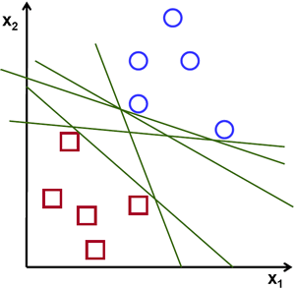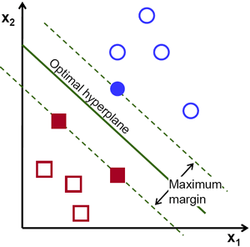

To separate the two classes of data points, there are many possible hyperplanes that could be chosen. Our objective is to find a plane that has the maximum margin, i.e. the maximum distance between data points of both classes. Maximizing the margin distance provides some reinforcement so that future data points can be classified with more confidence.

Hyperplanes and Support Vectors

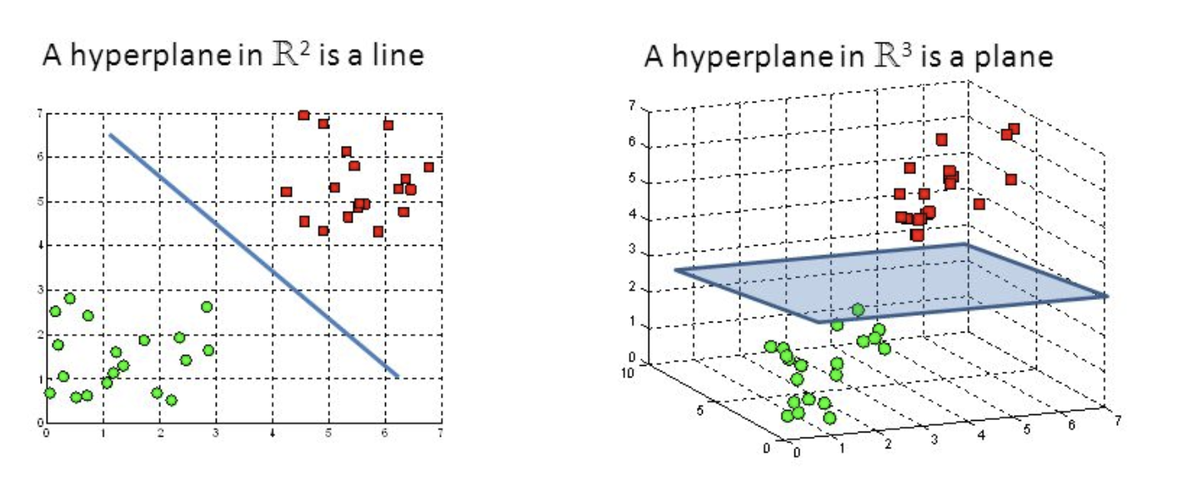
Hyperplanes in 2D and 3D feature space
Hyperplanes are decision boundaries that help classify the data points. Data points falling on either side of the hyperplane can be attributed to different classes. Also, the dimension of the hyperplane depends upon the number of features. If the number of input features is 2, then the hyperplane is just a line. If the number of input features is 3, then the hyperplane becomes a two-dimensional plane. It becomes difficult to imagine when the number of features exceeds 3.

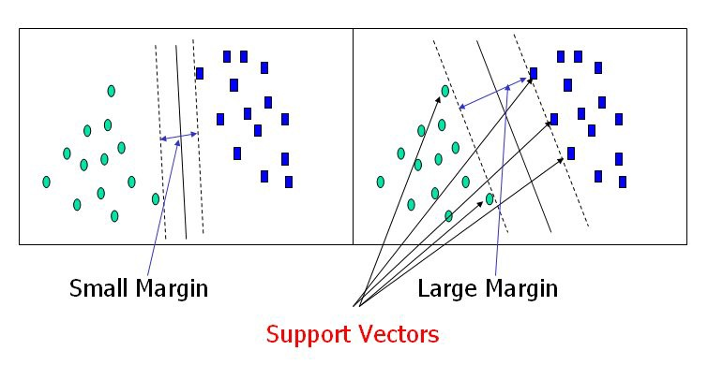
Support Vectors
Support vectors are data points that are closer to the hyperplane and influence the position and orientation of the hyperplane. Using these support vectors, we maximize the margin of the classifier. Deleting the support vectors will change the position of the hyperplane. These are the points that help us build our SVM.

Data Visualization: (for our problem)
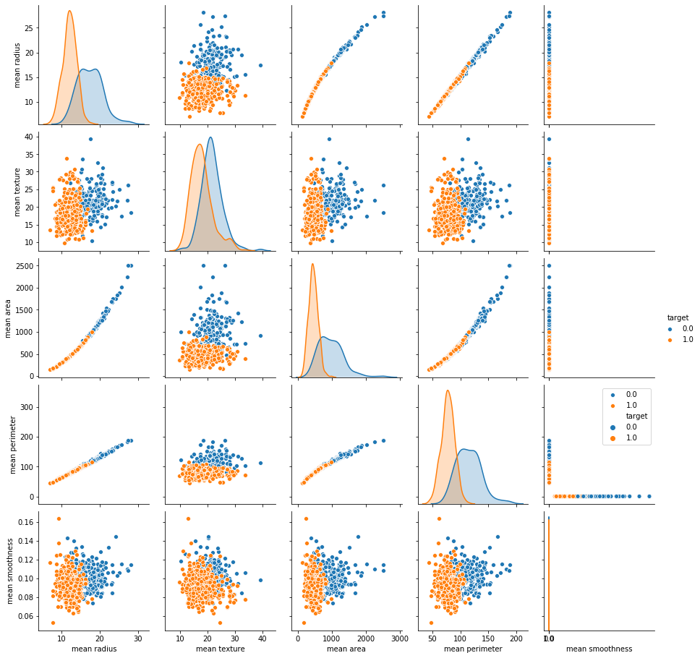

CONCLUSION
- Machine learning techniques (SVM) was able to classify tumours into Malignant/Benign with 97% accuracy.
- The technique can rapidly evaluate breast masses and classify them in an automated fashion.
- Early breast cancer diagnosis can dramatically save lives.
- The technique can further be improved by combining Computer vision/Deep Learning techniques directly from the cancer tissue images.
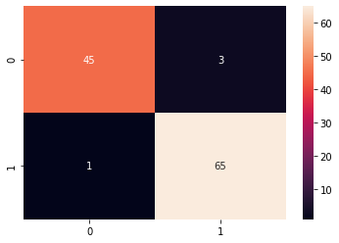
precision recall f1-score support

0.0 0.98 0.94 0.96 48
1.0 0.96 0.98 0.97 66

accuracy 0.96 114
macro avg 0.97 0.96 0.96 114
weighted avg 0.97 0.96 0.96 114

